1. **Beginners Challenge:** To Be or not to Be

Create a program asking the user “Who is the author of Romeo & Juliet?”.

If they enter “Shakespeare”, then print the message “Correct”

If they enter any other answer, print “Incorrect”

1. **Beginners Challenge:** Are you Positive?

Ask user to enter a number and tell them if the number is positive or negative

Draw a flow chart representing each path

1. **Intermediate Challenge:** Pass or Fail

Create a program that asks the user what they scored on a grade.

|  |  |
| --- | --- |
| **Score** | **Grade** |
| 90 or higher | A |
| 80 to 89 | B |
| 70 to 79 | C |
| 60 to 69 | D |
| 0 to 60 | F |
| < 0 or > 100 | error |

1. **Intermediate Challenge:**

Open Homework2.py from FCPSACE/Intro/tree/Input Output  
Update the program so if the user enters text instead of a number, the program does not crash

**Homework:**

1. Create a program that that greets the user to the movie theatre and tells them the price of their ticket based on the age which they entered.

|  |  |
| --- | --- |
| **Age** | **Price per day** |
| Under 12 | $8 |
| Between 13 and 59 | $14 |
| < 0 or > 100 | Print error |

1. Create a program asking the user to enter a number.   
   Tell the user if the number is odd or even

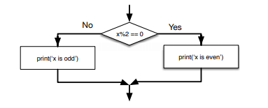

1. Create a program that asks the user how much they purchased. Store this as variable subtotal

Tell the user their total price given the following business requirements:

Shipping is $8

Purchases over $50 or purchases by prime members qualify for free shipping